- News You Can Use  This Month in Barbershop History:  “When O.C. Cash and Rupert Hall met in March 1938 in Kansas City, Missouri, they were passionate about preserving the quartet and harmony style of music. A month later in Tulsa, Oklahoma, they formed what today is known as the Barbershop Harmony Society.”  Select the below link to learn more.  History of Barbershop Singing is Rich  March Birthdays!  Let’s sing a very Happy Birthday in 4-part Harmony to our following members!  Travis Archer – March 7th  Mike Anderson – March 16th  John Wilcox – March 16th  Steve Whittaker – March 17th  Chuck Openlander – March 29th | Behind the C’s News  March 2022  Inaugural Issue!!  In February the Capital City Chordsmen rolled out its first Virtual Singing Telegrams for Valentine’s Day. As COVID continues to create barriers to in person appearances, we are finding new ways to celebrate and share our musical style that we love, and Valentine’s Day is the perfect holiday for us. We look forward to offering the Virtual Singing Telegrams next year and hopefully we can resume the in person singing telegrams next year. Several quartets offered their musical stylings to help make this a great kickoff event for us.  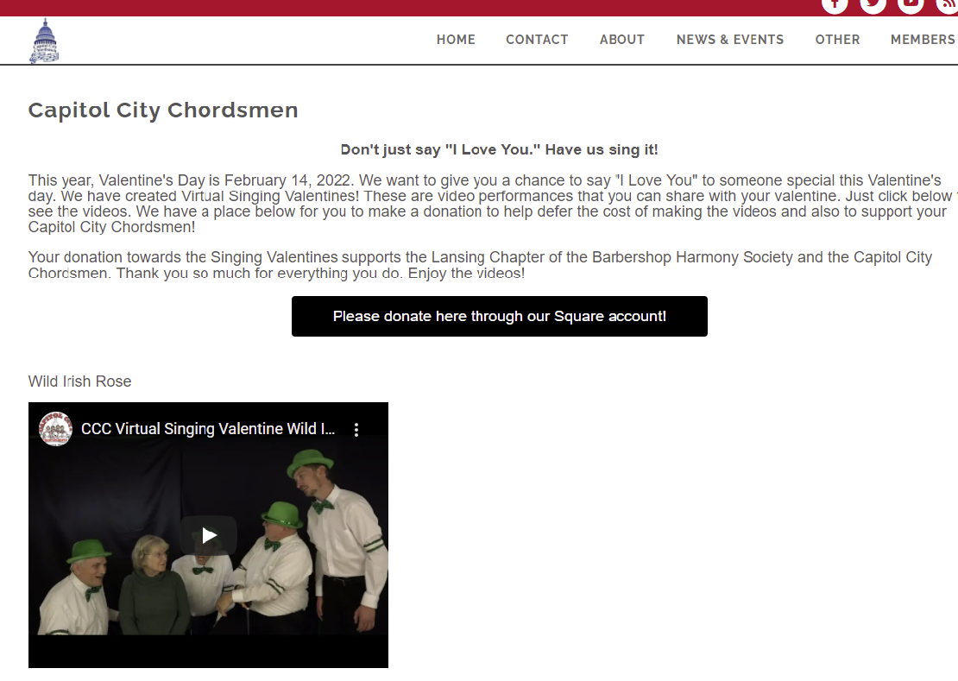  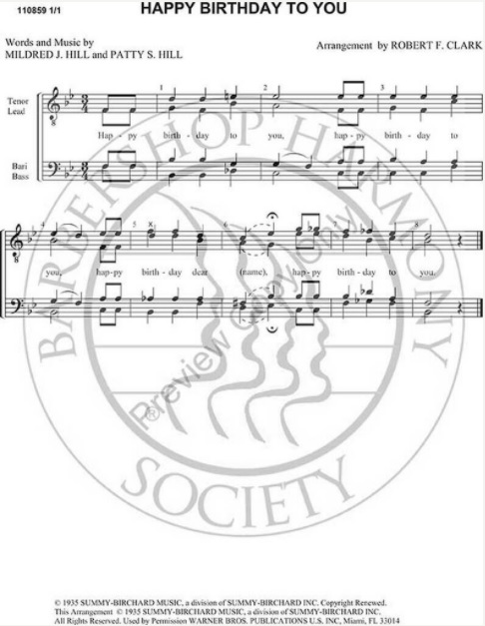  Noteworthy News  The history of the Capital City Chordsmen Video was recently updated and released. Select the link below to view this important historical preservation video of our chorus: History of Capital City Chordsmen  Jokes from Rich  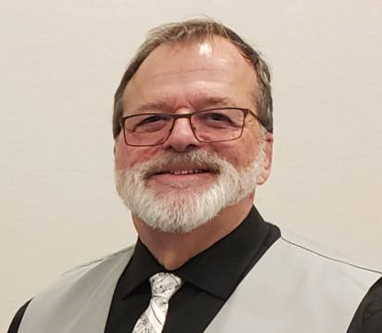  Joke: I just got a new pet, it's an amphibian. I named him "Tiny". Why did you name him "Tiny" you ask?  Because he’s, my Newt!  Singers Perspective: Brad Sharlow  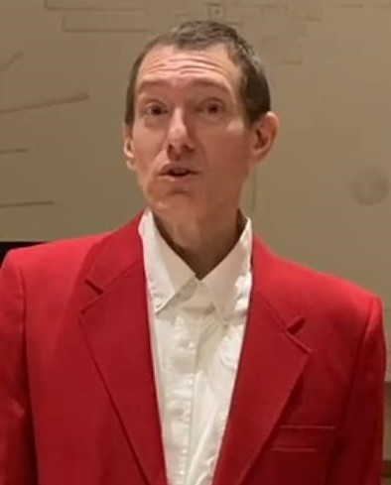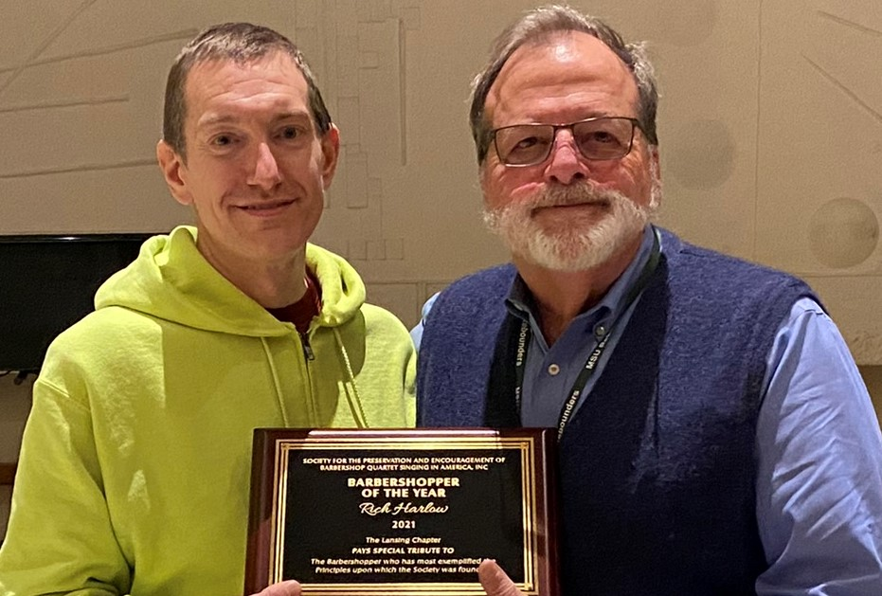  Brad Sharlow is one of the talented singers in our lead section. Here is an excerpt from his recent interview.  Question: If you had any advice for someone wanting to join the Chordsmen what would it be?  Answer: “I’d would just encourage them to come on Monday nights to our practices at the First Presbyterian church in Lansing. Notify one of us we’re always willing to come with you and work with you. Don’t feel intimidated by the music or whatever. We’re all here to welcome you and to help you and to have a good time…”  To enjoy the rest of the interview click here:
- Contact Us  Capitol City Chordsmen  510 W Ottawa St.  Lansing, MI 48933  Phone:  517-374-7464  Email:  Marketing@ capitolcitychordsmen.com  website www.capitolcitychordsmen.com | News from The Pioneer District  Spring 2022 Convention in  Grand Rapids  Written by Pioneer District. Updated at 3/1/2022, 12:27:19 PM  The Spring 2022 Pioneer District Convention will be held in Grand Rapids on April 29th & 30th.  The contest venue will be at the DeVos Center for Arts and Worship at Grand Rapids Christian High School, and the headquarter hotel will be the Doubletree Hotel on 28th Street.  Its OFFICIAL!!!!! The Oscar’s Show is ON  May 7, 2022, 7 pm First Presbyterian Church  510 W. Ottawa St. Lansing, MI 48933  Seating is Limited!!!  $10 General admission.  For tickets go to  www.capitolcitychordsmen.com

