Chordsmen News

November 2022

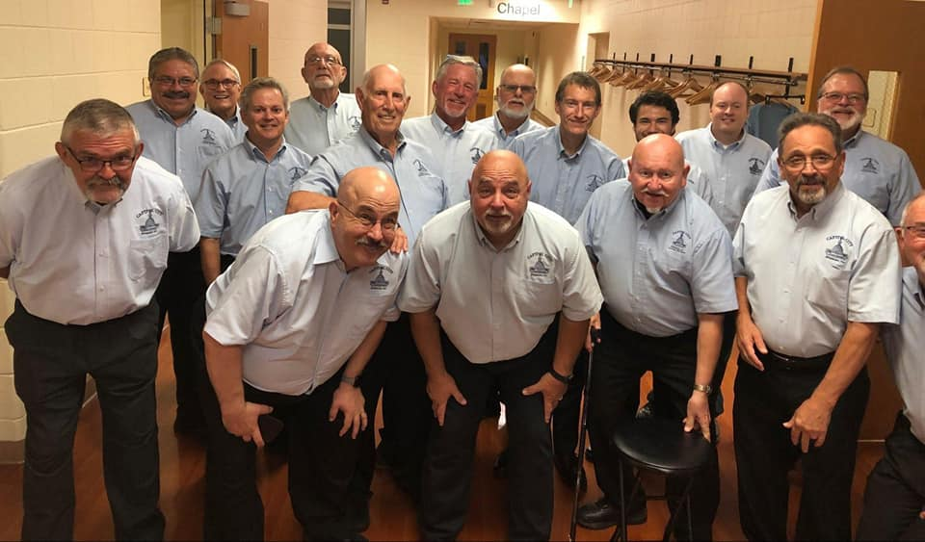

**Upcoming Events:**

Silver Bells in the City

Friday November 22 at 6 pm

The Chordsmen will be singing outside Insty Prints, 108 Washington Sq., Lansing

Advertisement for this event:

[Chordsmen Silver Bells in the City](https://youtu.be/y4nMbCDUpjM)

**Announcement:**

Annual Show is Upcoming!

Special Guests – 2022 International Quartet Medalists – Midtown

Also appearing – 2022 Pioneer District Champions – Chonk

Tickets going on sale soon!!!

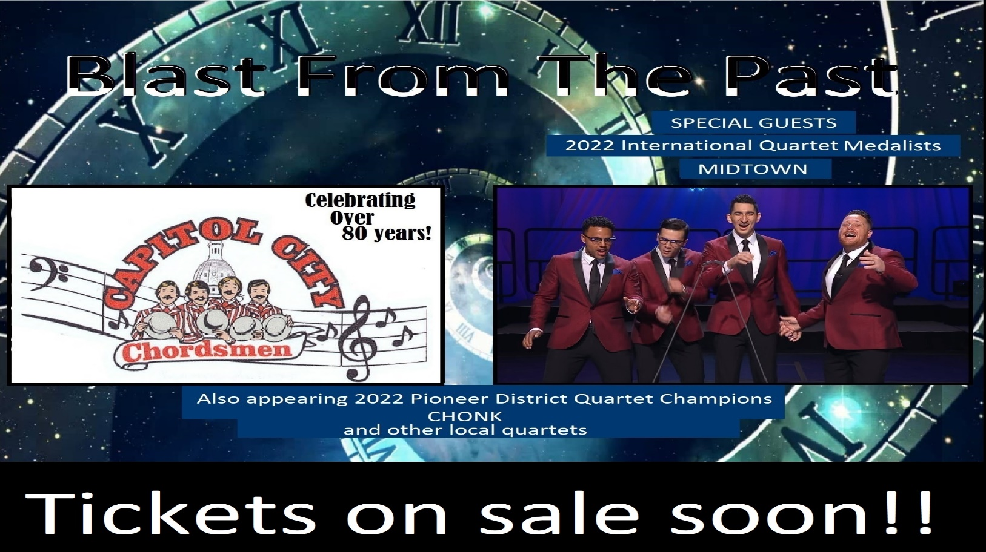

**Barbershop History**

“Sure, four striped-shirt, straw-hatted, bow-tied bodies — but five voices. The second tenor sets the stage with a lead melody line, which the first tenor lays a high harmony on. The baritone singer handles mid-range, while the bass, the deepest voice of the four, lays a solid foundation. But when the overtones of these four pitch-perfect voices unite and merge, an invisible fifth voice emerges from the ether, an everywhere-but-nowhere aural apparition not unlike the effect of Buddhist monks chanting in a massive ancient temple. This unified fifth-voice phenomenon is known as harmonic coincidence, though it is nowhere near a coincidence, accident, or fluke.” Read more at: [Barbershop-quartets-history](https://www.spin.com/2021/05/barbershop-quartets-history/)

**Happy Birthdays and Anniversaries**

* November 4 - Alan Zaeske (72 years young)

* November 6 - Dan Arnold - BHS Member 3 years

- Wally Plosky - BHS Member 3 years

* November 14 - Monty Batets (91 years young)

* November 26 - Ted Rahl (75 years young)

* November 29 - Paul Howe (79 years young)

**Joke of the Month**

What type of music should you listen to while fishing?

Something catchy