- News You Can Use  Scientists say singing boosts the immune system.  “Scientists say singing boosts the immune system  Singing strengthens the immune system, according to research by scientists at the University of Frankfurt in Germany, published in the latest edition of the US Journal of Behavioral Medicine. The scientists tested the blood of people who sang in a professional choir in the city, before and after a 60- minute rehearsal of Mozart’s Requiem. They found that concentrations of immunoglobin A – proteins in the immune system which function as antibodies – and hydrocortisone, an anti-stress hormone, increased significantly during the rehearsal.” -  Select the link below to learn more:  The Health Benefits of Singing - Barbershop.org  May Birthdays  Let’s sing a very Happy Birthday in 4-part Harmony to our following members!  Bruce Fitzpatrick – May 9  Mike Craig – May 26  Jacob Welty – May 30 | Behind the C’s News  May 2022  May is finally here and that means…  It’s almost time for A Night at The Oscars! Don’t forget to get your tickets. 244 tickets have been sold. Select the following link to purchase your tickets Capitol City Chordsmen.  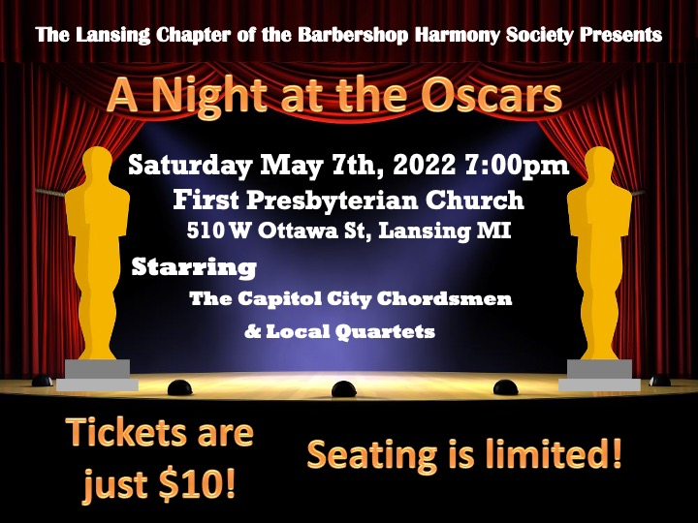  Noteworthy News  The following members are celebrating anniversaries this month with the Barbershop Harmony Society:  Dean Aroson – Celebrating 9 years  Travis Archer – Celebrating 10 years  Congratulations to our three Quartets who competed at The Great Reunion quartet competition at the Devos Center for Worship Arts in Grand Rapids.  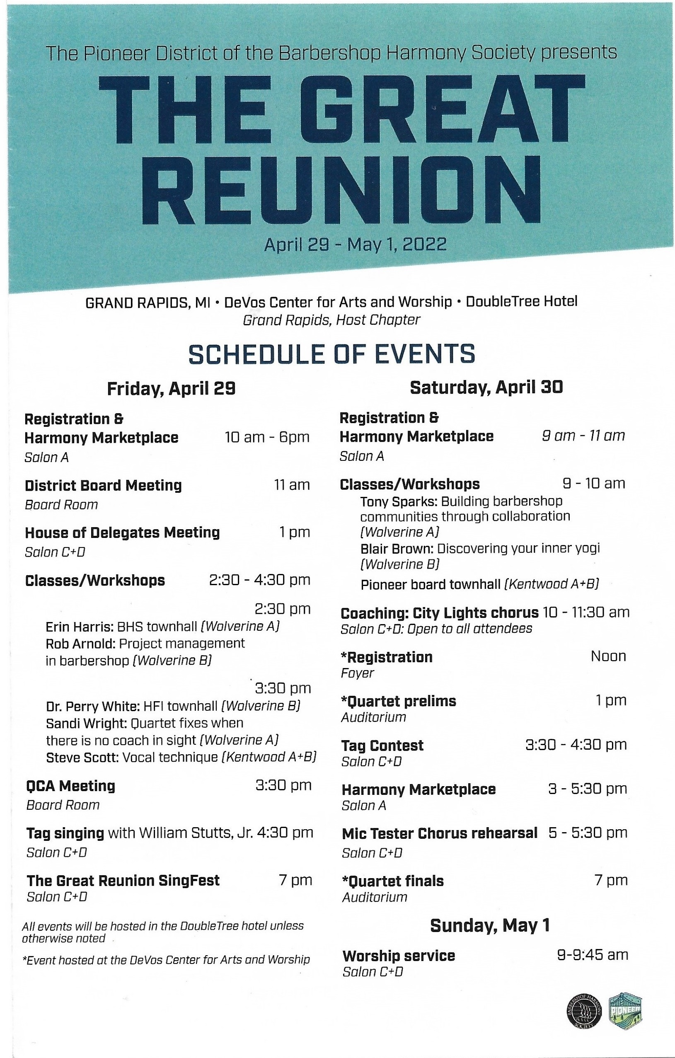  Can you find the names of the Quartets who completed at The Reunion?  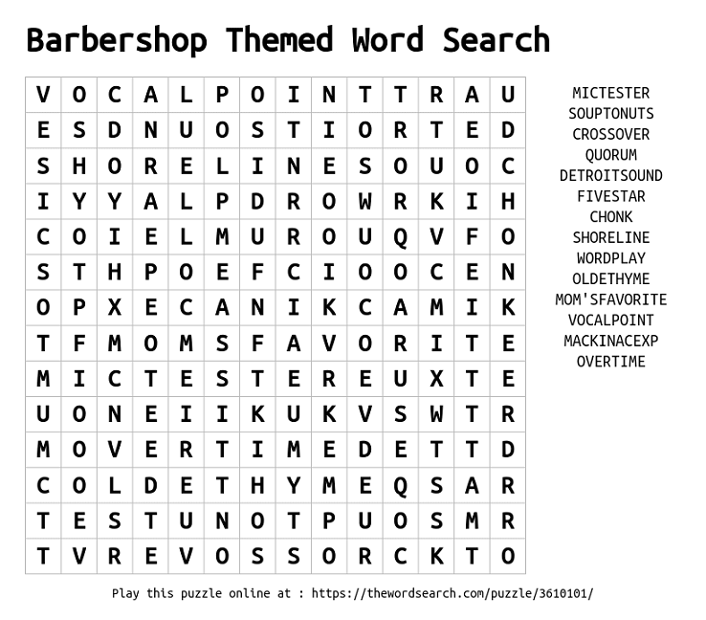
- Contact Us  Capitol City Chordsmen  510 W Ottawa St.  Lansing, MI 48933  Phone:  517-374-7464  Email:  Marketing@ capitolcitychordsmen.com  website www.capitolcitychordsmen.com | News from The Pioneer District  Shout out to our three quartests that competed in the The Great Reunion, Mackinac Express, Crossover and Old Time Harmony. With Mackinac Express making it to the finals.  