 | Capitol City Chordsmen |  | 
 | January 2023 News
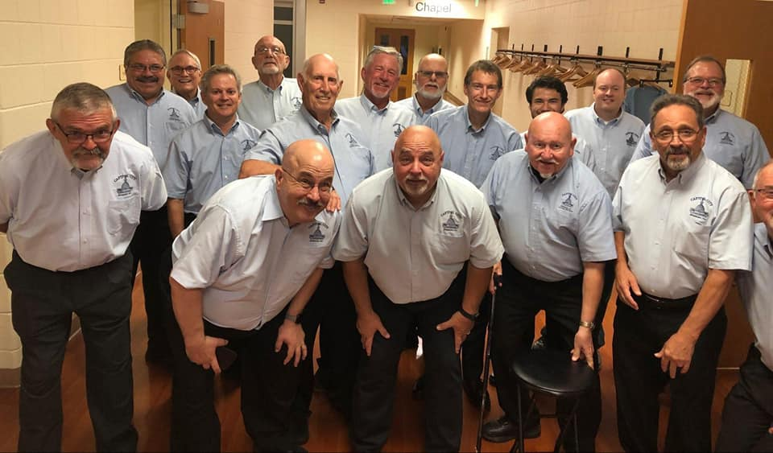
Upcoming Events:
 | No gigs on the schedule
Announcement:
Annual Show Tickets went on sale December 1st
Blast From the Past
March 4, 2023, 7 PM
- 2022 International Quartet Medalists – Midtown
- Also appearing – 2022 Pioneer District Champions – Chonk
Click here to purchase tickets
History of Barbershop: |  |  | Submitted by Don Horton
Here is an example of the chorus newsletter called “The Wood Shedder”. The date on this example is May 1972. Check it out.
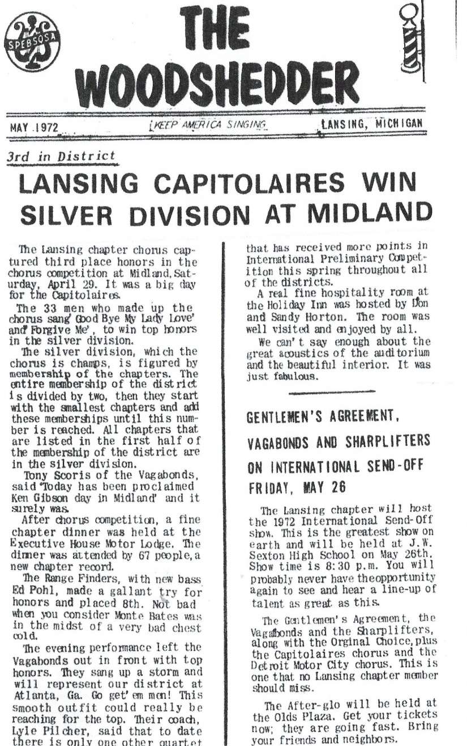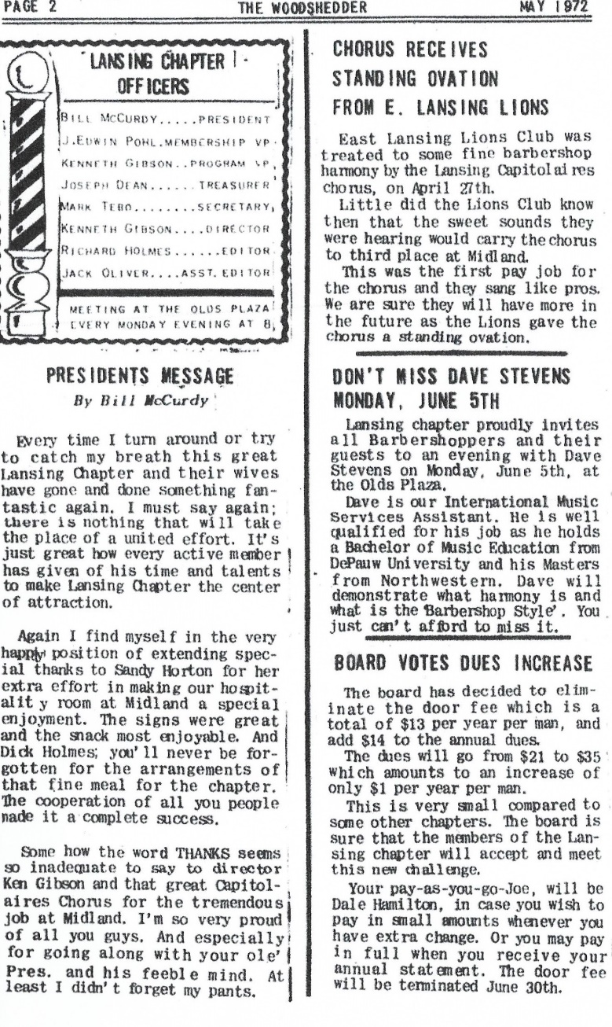

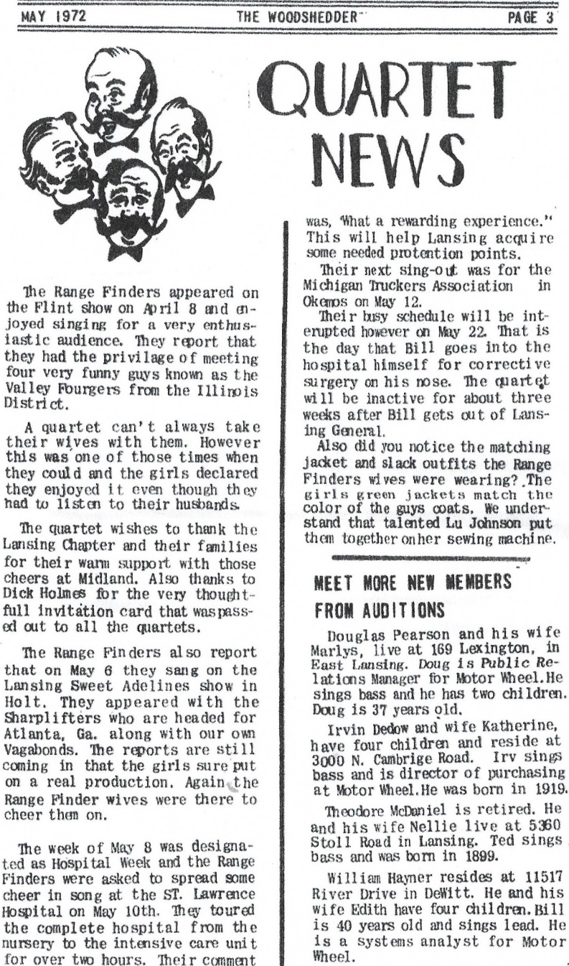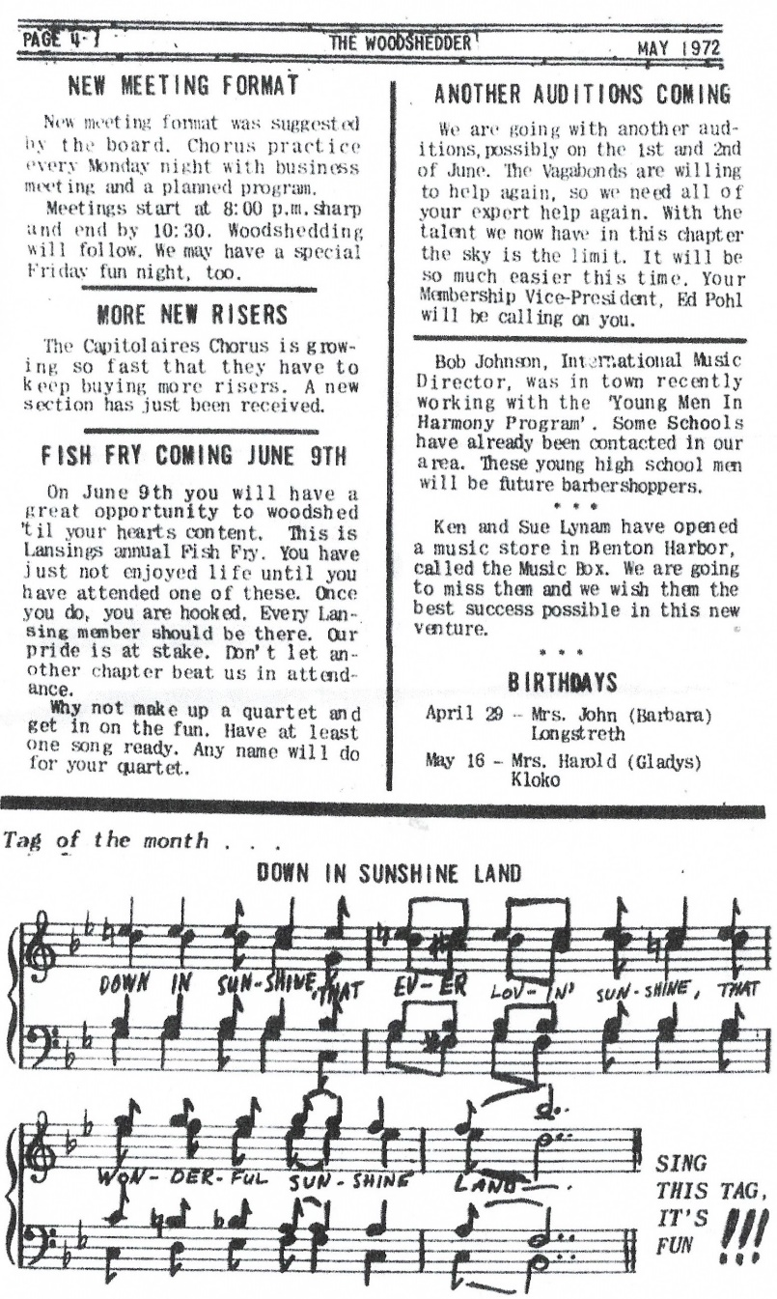
Letter from the Director: |  |  | Submitted by Brad Sharlow: Chorus Director
Vision for 2023 – Let’s Move Forward and Try to Grow. Year to “Take Off”.
I would like to challenge the chorus to implement the strategies we have discussed in our Five-Year Strategic Plan by setting some targets and deadlines. The last few years can be described as such: 2020 – “Disruption” Year; 2021 – “Reacquaintance” Year; 2022 – “Transition” Year. In essence, the last three years have been more of a survival and bounce back period. Now it’s time to move past that and look forward.
Vision for Chorus: The Capitol City Chordsmen will be a growing chapter for all men that strives for musical excellence, to entertain audiences with quality performances while creating a brotherhood through enjoyment and fellowship with chapter members.
2022 Accomplishments:
- 9 Performances over 7 months
- 30 singers participated in the 8 performances since July.
- Averaging between 12-19 people per performance
- Rehearsals – 10-20 people per rehearsal, averaging around 14-15.
- 3 New BHS Members
- 4 guests who performed in at least one performance
- 2 new quartets are forming to sing in the 2023 show
- 2 established quartets attended Bush League and came home with 2nd and 3rd place trophies.
- Attended our first convention (with 14 singers) in 3 years and set a new baseline (within 1% of winning the small chorus trophy).
2023 Goals and Targets:
- Have 20 people attend each rehearsal (asking each chorus member to commit to being at 75% of rehearsals over the course of the year).
- 12 performances (5 are already booked).
- 25 singers in each performance
- 30 singers in our annual show
- Membership and Recruiting – ask each chorus member to commit to bringing 1 guest over the year to a rehearsal.
- Retaining Members – ask each chorus member to reach out to a former guest or member to invite them back
- Quartets – have 5 total chapter quartets active and available to sing at chorus performances.
- Have 20 singers committed to Spring and Fall Conventions
- Have 20 chorus members participate on a committee (either backing up a board member or an ad hoc committee). We need to have more representation from the full chorus on our committees. Currently, most committees and ad hoc roles are served by the current 10-11 board members, and they are serving multiple hats. Examples of subcommittees include: show committee, music committee, promotion (marketing/advertising and membership recruitment) committee, etc.
Ways to achieve these targets:
- Re-introduce the Five-Year Strategic Plan and have everyone read through this.
- Educate members on the five seasons of our calendar year and use this as a recruitment and retainment strategy (as people seem intimidated to participate as they feel it’s a year-long commitment). Allow people to decide which seasons they would like to be more active in, and coordinate with the Director, so he can know who to count on when for each performance. The five seasons are as follows:
  - January to early March – Annual Show
  - Mid-March to April – Spring Convention
  - May to Mid-August – Summer Shows
  - Late August to mid-October – Fall Convention
  - Late October to December – Christmas Shows
- Develop more effective communication channels for expectations.
- Develop an official chorus calendar where all the details of rehearsals, performances and committee meetings are included. Currently, we have pieces of these on our spot reports, website and through emails, but we need a one-stop shop for all events.
- Standardize the singing enhancement program and find a way for it to work for all singers. Responsibility: The Music Committee shall make this a priority for the year.
- Encourage additional two members to attend District meetings. Currently, President and Treasurer are the only two members who attend regularly. The more people who get engaged with the District and District activities, the more engaged they will become with overall chapter singing and performance opportunities
- Promote quartet singing opportunities during rehearsals and performances
- Promotion Committee formation: include chapter development and marketing vps, and other chapter members who are good at recruiting, advertising, engaging potential new singers, etc.
- Follow through on University Grant Program and begin partnership with MSU.
- Develop quarterly Saturday workshops to teach new concepts, music theory, or other training opportunities.
Director Commitments
- Continue to train and be educated in Barbershop Directing and Leadership
- Attend Harmony University in July 2023 if allowed through board
- Continue coaching with assistant directors
- Continue bringing new musical ideas to members to assist in singing and tuning
- Continue to provide timely rehearsal itineraries and effectively communicate plans
- Invest in a wireless microphone to use during rehearsals
- Bring in coaches to provide fresh ideas for music, singing and performance enhancement
Message from our President: |  |  | Submitted by Ted Rahl: Chapter President
"Another year over and a new one just begun". That lyric was written in 1971 by Yoko Ono and John Lennon. Each year when I hear that song over the holidays it brings back to me the past and gives me hope for the future. Each new year brings us pause to reflect on the past year and look forward to the new one.

As a chapter we have a long history. More than 80 years of singing and performing. The last few years have been very significant with the pandemic and the way the society around us has changed. Barbershop harmony is evolving. But we have stayed together as a chorus. Our chapter is strong. Our love of harmonizing and entertaining, sharing our passion for our hobby is still vibrant. Our future I believe is bright.

Moving forward I hope we continue to grow. To grow in membership, yes, but to grow in our relationships with each other. To continue support for one another, musically and people passionate about our music. Not just as we say, "keep the whole world singing", but keep sharing our music with audiences and bringing our joy of our music to the community around us.

Which is why I am so happy that our chapter was supportive of producing our first annual show since 2019. It will be great to be on stage again and share our music after three long years. A big undertaking but well worth the work it will take to present the best show ever. A labor of love if you will excuse my enthusiasm.

Can't wait to get back on the risers with you for the new year and a great show.

“It's GREAT TO BE A BARBERSHOPPER!!!”

Ted Rahl
President Lansing Chapter
Happy Birthdays and Anniversaries:
- January 3
- Mike Roberts - member of Lansing Chapter SPEBSQSA Inc 4 years
- January 10
- Daniel Schneider - member of Lansing Chapter SPEBSQSA Inc 4 years
- January 12
- TR Gerard Birthday (70 Years Young)
Joke of the Month:
 | - Why do tenors stay away from steamrollers? They'd hate to do a slide and end up flat.
 | 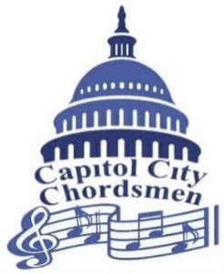
 | Capitol City Chordsmen
 | First Presbyterian Church
 | 510 W Ottawa St
 | Lansing MI 48933
 | (517) 372-7464
 | Click below for our:
 | Website
 | YouTube channel
 | Facebook Page
 | Instagram Page
 | Twitter Page

