- Capital City Chordsmen News You Can Use  This month’s news features the History of The Sweet Adelines:  Sweet Adelines International was established in 1945 by Edna Mae Anderson of Tulsa, Oklahoma. The aim was to teach and train its members in music and to create and promote barbershop quartets and other musical groups. She gathered a group of women who wanted to participate in the "chord-ringing, fun-filled harmony" that their husbands, members of the men's Society for the Preservation and Encouragement of Barbershop Quartet Singing in America (SPEBSQSA), were singing. SPEBSQSA has since changed its name to the Barbershop Harmony Society.  Select the below link to learn more.  Sweet Adelines International  The | Behind the C’s: News  August 2022  A Night of Acappella  This month the Capital City Chordsmen along with Mackinac Express are excited to be joining Fenton Lakes Chorus with Fleetwood Four and Riot Act for A Night of Acapella. The show is presented by Capital Acapella at Lansing Catholic High School Auditorium at 501 Marshall St., Lansing, MI 48912 on Saturday August 6, 2022 at 7pm. Doors open at 6:30. This is a free event so be sure to invite family and friends.  Take Me Out to the Ballpark!  The Chordsmen will be singing the National Anthem on Thursday, August 18th for the Lansing Lugnuts’ vs The Great Lakes Loons at Lugnuts’ Jackson Field Stadium. The Chordsmen will also be performing in the mezzanine. Be sure to come out and enjoy Baseball and Barbershop Music!  Birthdays and More!  Let’s sing a very Happy Birthday, in 4-part harmony of course, for our August birthdays:  James Hall – August 2nd  Joel Schneider – August 6th  Don Horton and Sandy’s anniversary – August 8th  Johnny Kiel – August 11th  Steve Warnaar – August 15th  George Lorimer – August 19th  Garry Rowe – August 24th  Kevin Lenneman – August 25th  Noteworthy News  July 15th The Capital City Chordsmen had the opportunity to sing at Good Sam’s Camping Club in Branch County. Everyone had a great time.  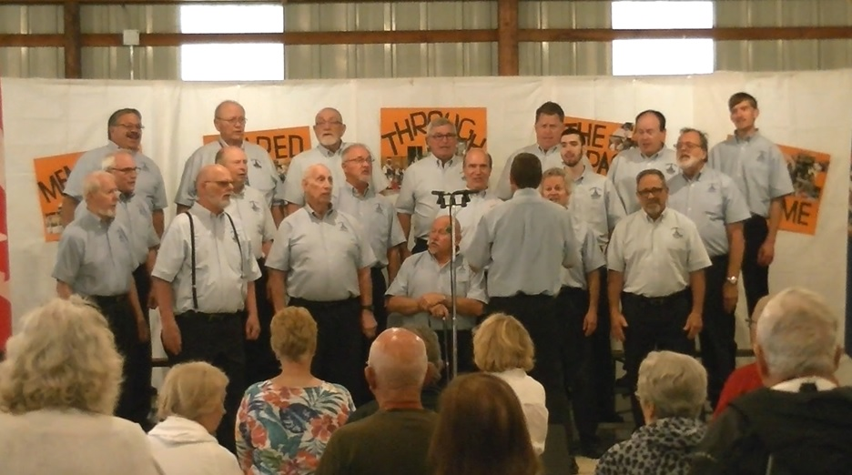  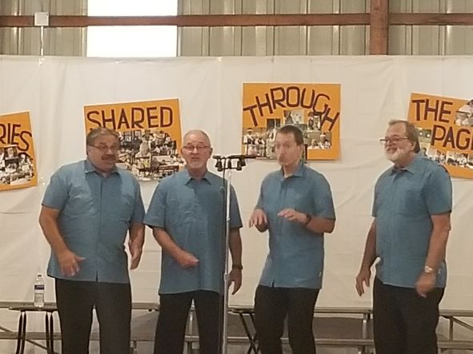  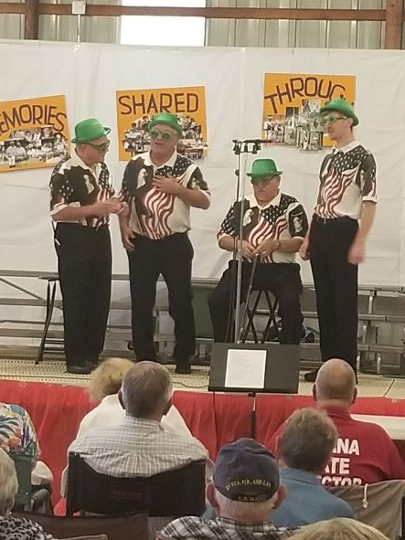  We officially have a proclamation for A Call to Sing!  If you know of anyone who enjoys singing invite them to visit our Tuesday night rehearsals at First Presbyterian Church in downtown Lansing at 7pm. If you know of a prior member, invite them to return! Word of mouth is vitally important to growing our numbers and a way to spread the message of Keeping the Whole World Singing!  t

