- News You Can Use  This Month in Barbershop History:  “On April 11th, toes start tapping to four-part harmony thanks to National Barbershop Quartet Day. Barbershop quartets have a way of making the heart flutter. Very often, they transport us back to a simpler time or at the least make it standstill.  Select the below link to learn more.  National Calendar Barbershop Quartet Day  April Birthdays  Let’s sing a very Happy Birthday in 4-part Harmony to our following members!  Rick Mills - April 11th  David Koch - April 27th | Behind the C’s News  April 2022  April Showers Bring May Flowers  Or in this case, showers of excitement for the Capital City Chordsmen annual show, A Night at The Oscars! Get your tickets soon, as at the time of the newsletter being published 175 tickets have been sold. Select the following link to purchase your tickets Capitol City Chordsmen.  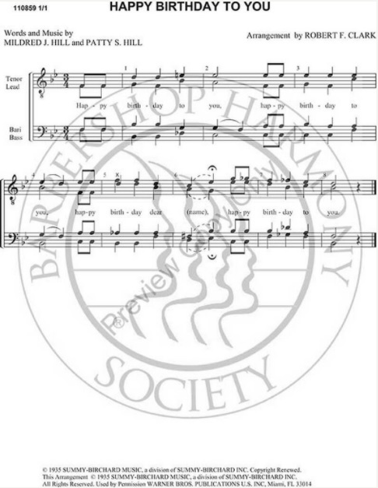  Noteworthy News  The history of the Capital City Chordsmen Video was recently updated and released. Select the link below to view this important historical preservation video of our chorus: History of Capital City Chordsmen  Jokes from Rich  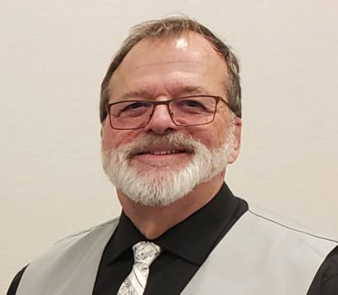  “Bill, our baritone is from Buffalo, the rest of us are from normal parents….”  “If you eat pasta and antipasto at the same time will you still be hungry?”  “What do you get when you cross a Frenchman and a janitor? Jacques custodian!”  A Barbershop Themed Word Search  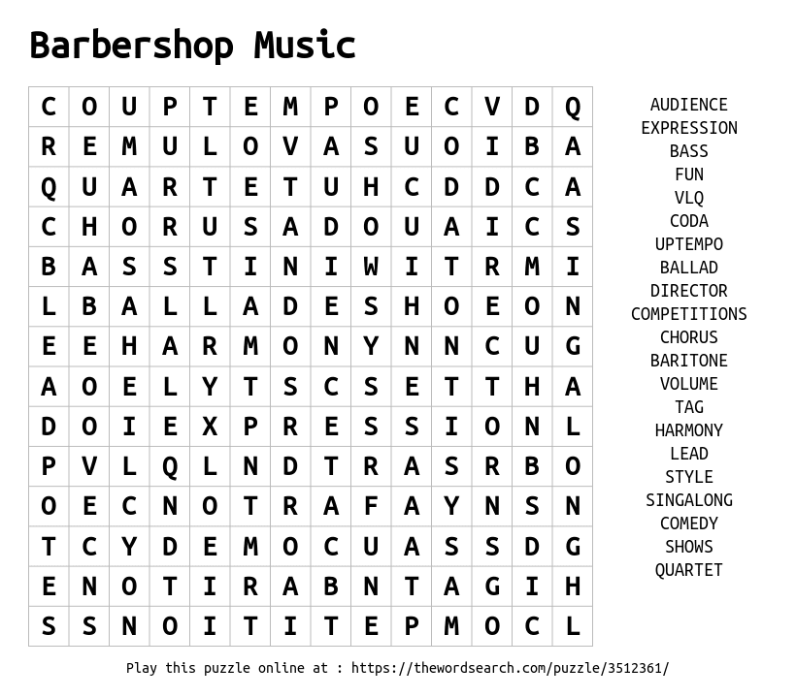
- Contact Us  Capitol City Chordsmen  510 W Ottawa St.  Lansing, MI 48933  Phone:  517-374-7464  Email:  Marketing@ capitolcitychordsmen.com  website www.capitolcitychordsmen.com | News from The Pioneer District  Spring 2022 Convention in Grand Rapids  Written by Pioneer District. Updated at 3/1/2022, 12:27:19 PM  The Spring 2022 Pioneer District Convention will be held in Grand Rapids on April 29th & 30th.  The contest venue will be at the DeVos Center for Arts and Worship at Grand Rapids Christian High School, and the headquarter hotel will be the Doubletree Hotel on 28th Street.

